Ideation Phase
Define the Problem Statements

Date | 19-02-2026
Team ID | LTVIP2026TMIDS66321
Project Name | Cafeteria Menu Display
Maximum Marks | 2 Marks

Customer Problem Statement :
In many cafeterias, menu information is currently displayed using static printed boards or verbal communication from staff. These methods make it difficult to update menu items, prices, availability, and special offers in real time. As a result, customers often face confusion, long waiting times, and incorrect order placement. Cafeteria staff also spend extra effort repeatedly explaining menu details, leading to inefficiency and reduced customer satisfaction.
There is a need for a digital cafeteria menu display system that can dynamically show updated menu items, prices, availability status, daily specials, and announcements in a clear and attractive manner. The system should be easy to update, cost-effective, and capable of improving customer experience while reducing staff workload and operational errors.
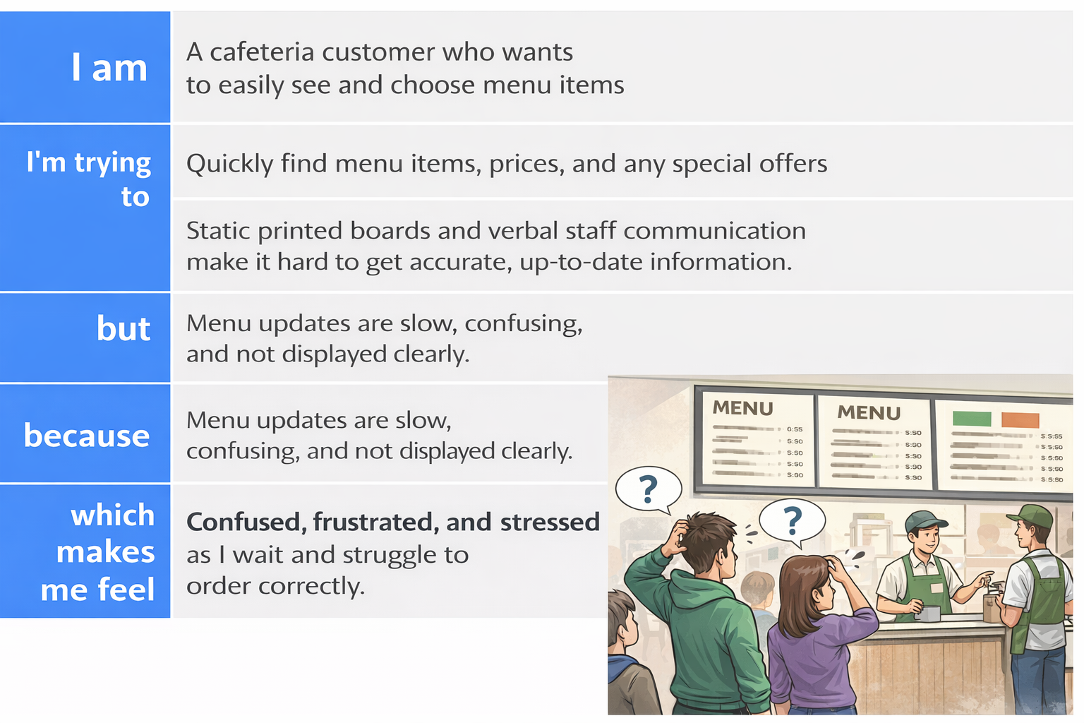
Reference: https://miro.com/templates/customer-problem-statement/

Example:
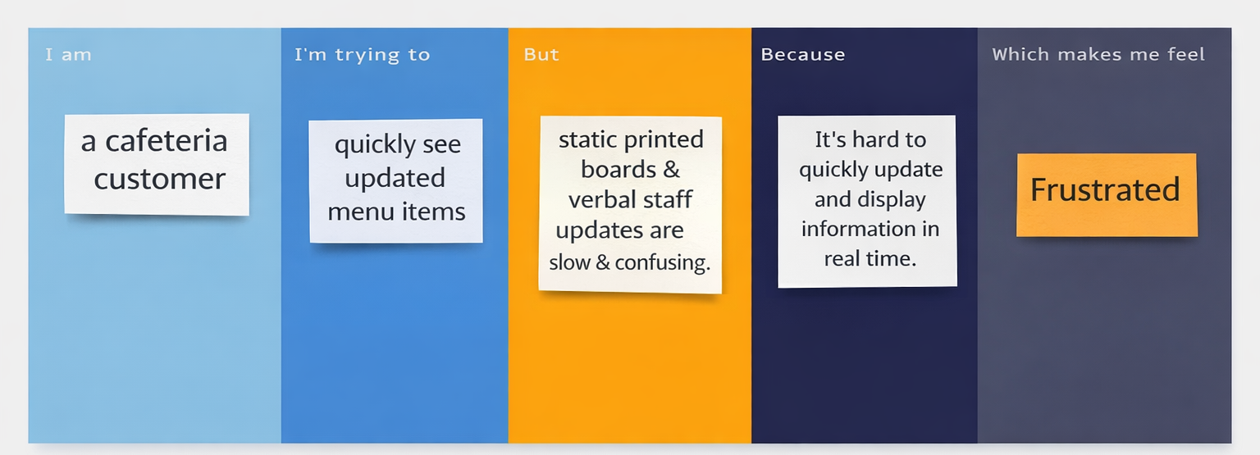

Problem Statement (PS) | I am (Customer) | I’m trying to | But | Because | Which makes me feel
PS-1 | A student | Quickly decide what to have for lunch | Menu is available only on a static, hard to read board far from the counter | I have limited time during my break and can’t easily see all options or nutritional info | Frustrated and rushed
PS-2 | A cafeteria staff member | Update the daily specials and prices efficiently | I have to manually print and replace the paper signs every morning | It is time-consuming, wasteful, and prone to errors | Stressed and inefficient

